Final

Brandon Trinkle

Arizona State University

Course Number: IFT 210

Professor Rick Bird

2/20/2024

Reflection

Test Case 1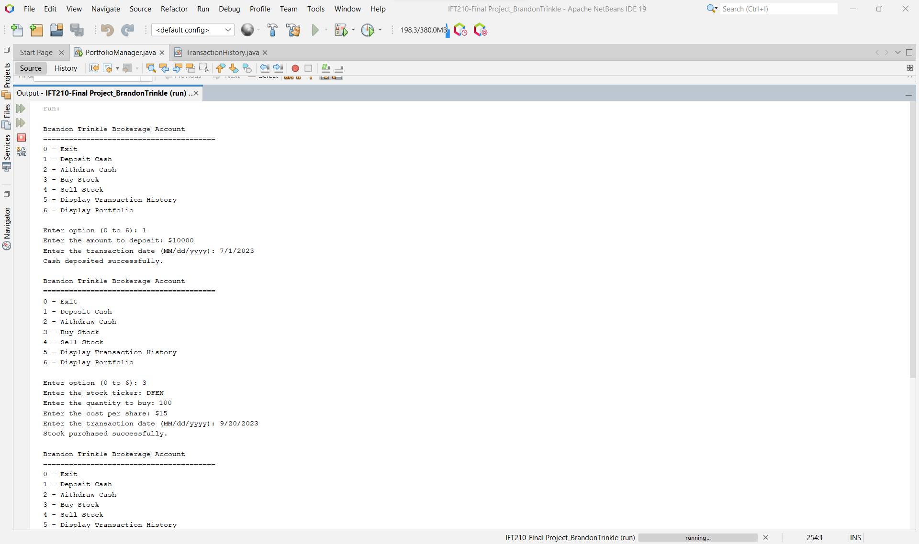

**Test Case 2**

**Test Case 3**

